Lab - Configuring a DHCP Superscope in Windows Server 2012 R2

Overview

In this lab, students will learn how to configure a DHCP Superscope in Server 2012 R2. DHCP superscope is a **collection of individual scopes that are grouped together for** administrative purposes. This configuration allows client computers to receive an IP address from multiple logical subnets even when those clients are located on the same physical subnet. You can create a superscope only if you have created two or more IP scopes already in DHCP.

Requirements

* Server running Server 2012 R2 with the DHCP Server role installed.

Begin the lab

Login onto you Server 2012 R2 machine. Go to Server Manager, Go to Tools and from the tools menu select DHCP.

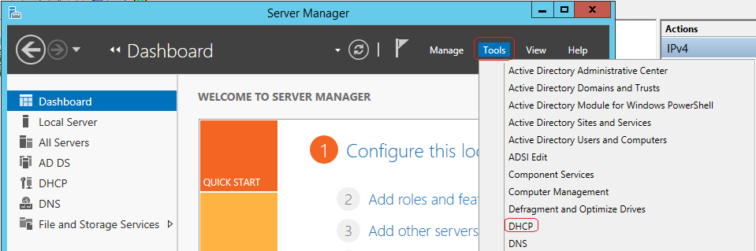

Create Scope 1

From the left window pane, right click on IPV4 and from the context menu, select New Scope.

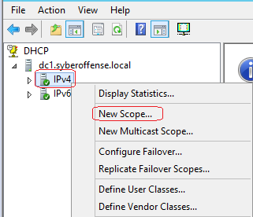

Once the new Scope Wizard opens, click next.

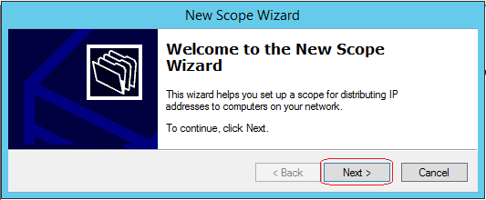

On the next page, name your scope and add a description. Click Next.

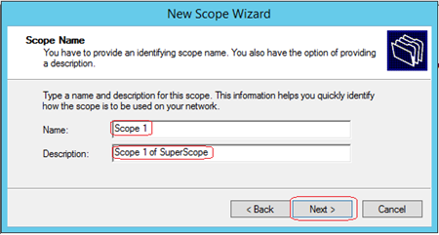

Fill in your IP range.

It should be noted that the only way to change this information it to delete the scope and start over.

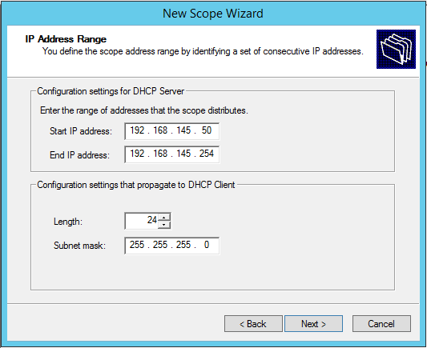



If asked on the 70-410 exam, how to change the IP range on an existing scope, what would your answer be?

Answer: Delete the scope.

At the Exclusions and Delay page, click next.

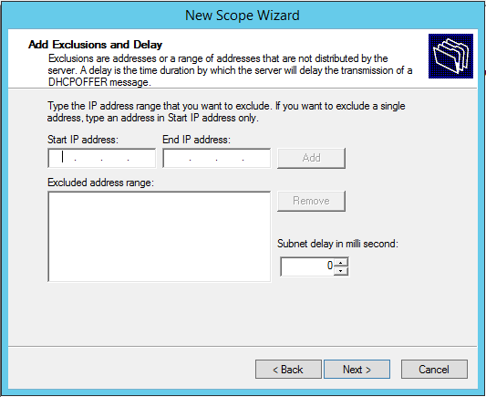

At the Lease Duration page, click next.

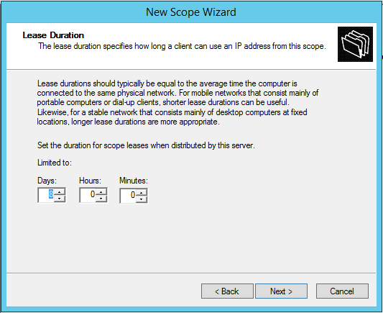

On the Configure DHCP Options page, select “****Yes, I want to configure these options now**** “and click Next…

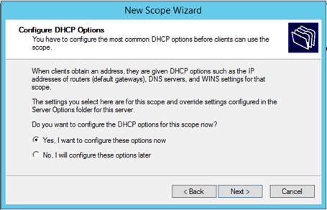

On the **Router** (Default Gateway) page, in the IP address box, type **192.168.145.1** click **Add** and then click **Next**.

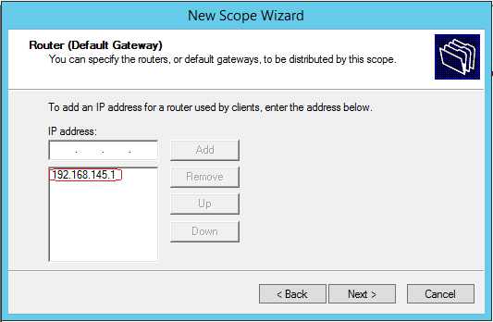

On the Domain Name and DNS Servers page **verify your parent domain is correct** and click next.

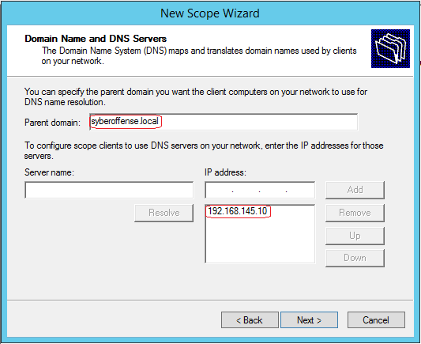

On the WINS Servers page click **Next**

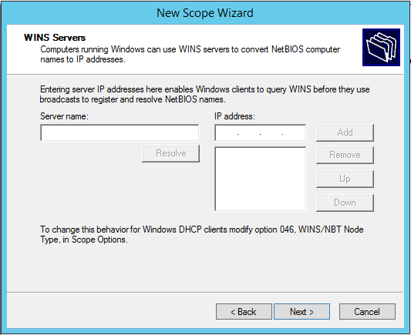

 On the Activate Scope page, click “**No, I will activate this scope later**” and click **Next.**

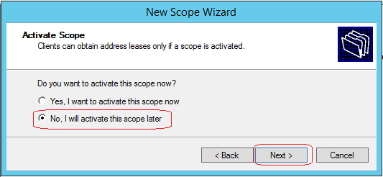

On the Completing the New Scope Wizard page, click **Finish.**

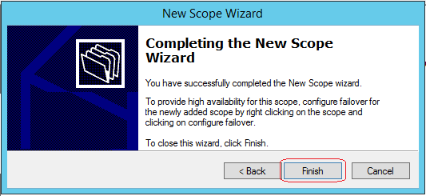

Create Scope 2

**Right click on IPv4** and click **New Scope**, click Next and then on the Scope Name page, in the Name box, type **PD Site Scope**, and then click **Next.**

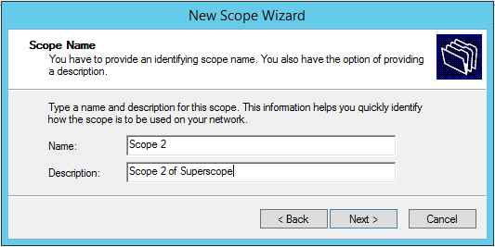

On the IP Address Range page, for the **Start IP address** box, type **192.168.2.50**, and then, in the End **IP address** box, type **192.168.1.254**, accept the default Class C subnet mask and click **Next**.

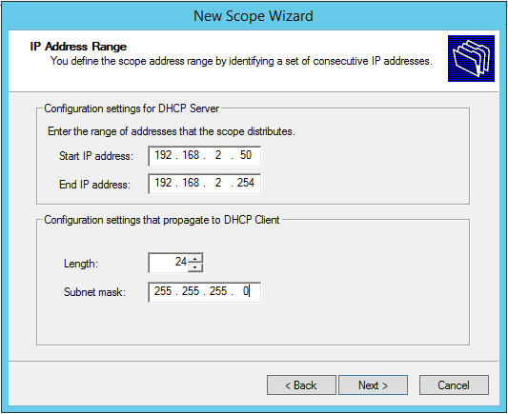

At the Exclusions and Delay page, click next.



At the Lease Duration page, click next.



On the Configure DHCP Options page, select “****Yes, I want to configure these options now**** “and click Next…

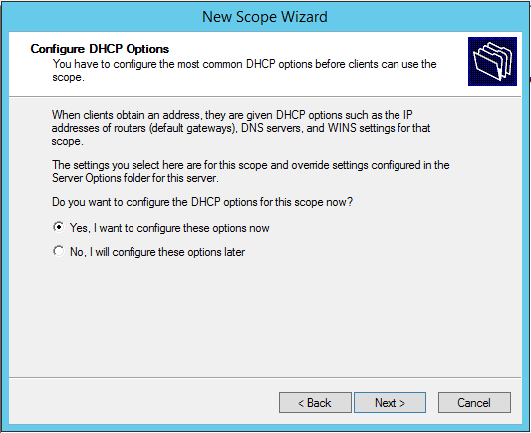

On the **Router** (Default Gateway) page, in the IP address box, type **192.168.2.1** click **Add** and then click **Next**.

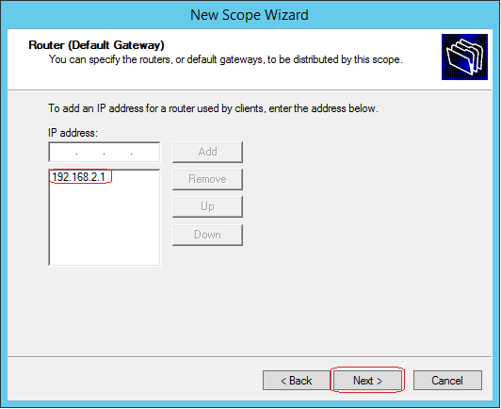

On the Domain Name and DNS Servers page **verify your parent domain is correct** and click next.



On the WINS Servers page click **Next**



 On the Activate Scope page, click “**No, I will activate this scope later**” and click **Next.**



On the Completing the New Scope Wizard page, click **Finish.**



Configure a Superscope

Right-click the IPv4 node, and then click **New Superscope.**

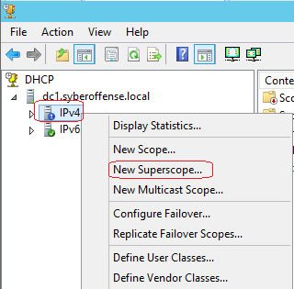

The New Superscope Wizard starts, click **Next**.

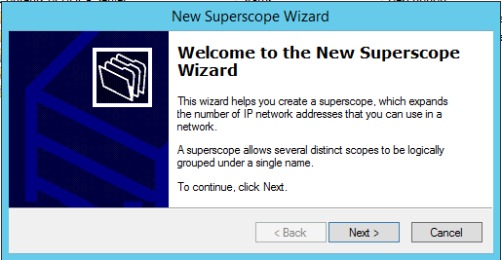

On the **Superscope Name page**, give your scope a user-friendly name and click **Next.**

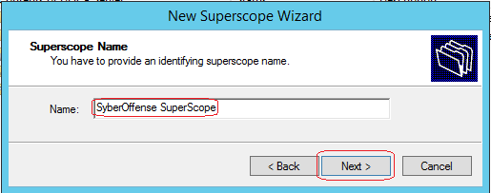

On the Select Scopes page, select **Scope 1**, **hold down the Ctrl key**, select **Scope 2** and click  
**Next**.

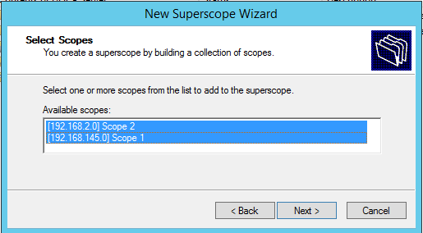

On the Completing the New Superscope Wizard interface, click **Finish**.

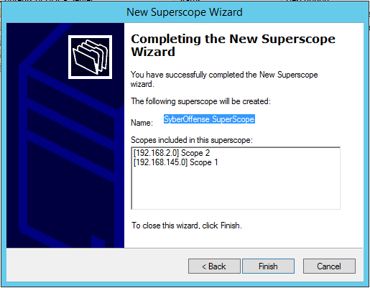

 In the DHCP console, select, expand and then right-click the name of your SuperScope, and then click **Activate**.

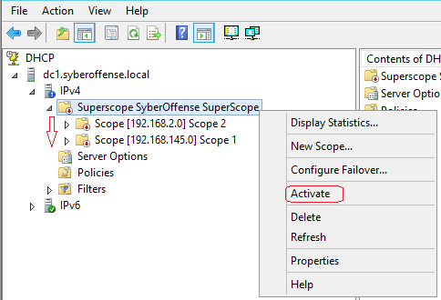

End of the lab!